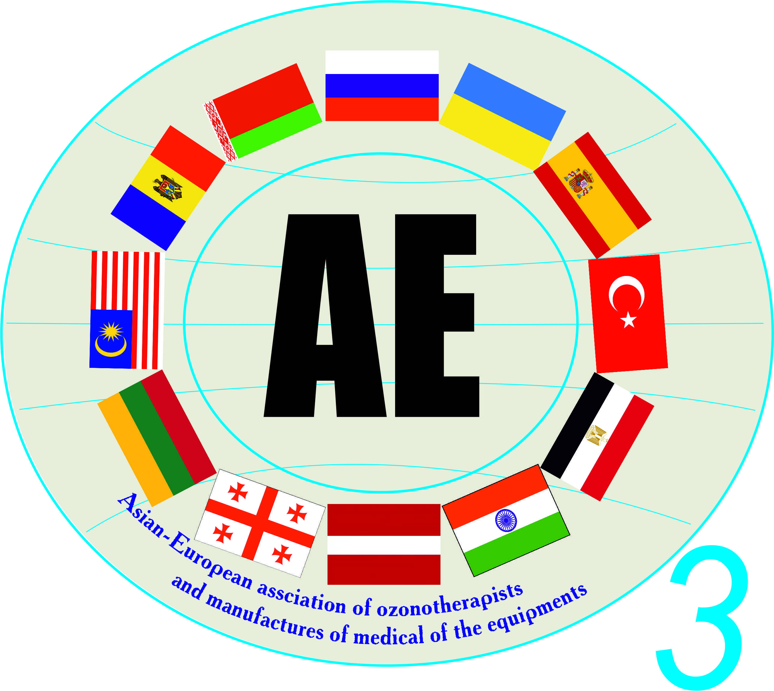
VII ASIAN AND EUROPEAN
SCIENTIFIC INTERNATIONAL CONFERENCE

OZONE AND OTHER MEDICAL GAS IN BIOLOGY AND THERAPY

CONFERENCE PROGRAM
Dear colleagues!
You are invited to take part at the VII Asian and European scientific international conference on the theme “Ozone and other medical gas in biology and therapy” which will be held in Tbilisi, Georgia, on 26 – 28 May 2017.

The following issues are submitted for consideration by the Conference program:

1. Experimental researches in the field of ozone and other medical gas use in biology and therapy.
2. Mechanism of ozone and other medical gas action on biological objects.
3. Biochemical and biological methods for monitoring the effectiveness and safety of ozone therapy.
4. Clinical aspects of the medical gas use.

The time allocated to presented reports will be around 20 minutes. The reports will be presented through a multimedia projector (presentation in MS PowerPoint format 2000, ХР).

The registration of participants and visitors of the conference will be held on 26 May from 9 a.m. in the conference room of the State medical university of Tbilisi.

26 May 2017

10:00 Opening of the conference: Dr.Med.Sci., Professor Boyarinov G. A. – honorary president of the Asian and European Union of ozone therapists and medical equipment manufacturers
Presidents:
Prof. Kontorshchikova K.N. - Medical academy, Nizhny Novgorod, Russia.
Prof. Maslennikov O.V. - Medical academy, Nizhny Novgorod, Russia.
Prof. Nazarov Y.I. - Executive president of the Asian and European Union of ozone therapists and medical equipment manufacturers, Ukraine.
Prof. Peretyagin S.P. - President of the Association of Russian ozone therapists, Nizhny Novgorod, Russia.
Dr. Talakwadze V.V. - President of the Association of Georgian ozone therapists, Tbilisi, Georgia.
Prof. N. Lüleci - President of the Association of ozone therapists of Turkey, Istanbul, Turkey.
Dr. M. Sallinen - President of the Association of ozone therapists of Finland, Vantana, Finland.

10:30 – 13:00 THE FIRST PLENARY SESSION
Presidents: Professor Nazarov Y.I., Professor Kontorshchikova K.N.
10:30 - 10:50 Dr. Miika Sallinen, President of the Association of ozone therapists of Finland, Vantana, Finland.
Report: Early history of ozone therapies.

10:50 - 11:30 Ass.Prof.Biol.Sci., Professor Kontorshchikova Klavdiya Nikolayevna, Medical academy of Nizhny Novgorod, Russia.
Report: Biochemical basis of efficiency and safety of the ozone therapy.

11:30 - 12:10 Dr.Tech.Sci. Nazarov Yevgheniy Ivanovic, the Asian and European Union of ozone therapists and medical equipment manufacturers, Odessa, Ukraine.

Report: Synergy of ozone and hydrogen physiological activity.

12:10 - 12:30 Dr.Med.Sci., Boyarinov Ghennady Andreyevic, the Asian and European Union of ozone therapists and medical equipment manufacturers, Nizhny Novgorod, Russia.
Report: Antibacterial, fungicidal and viricide effect of ozone.
12:30 – 13:10 Dr.Med.Sci., Professor Maslennikov Oleg Viktorovic, Nizhny Novgorod, Russia.
Report: Use of the ozone therapy for diseases associated with atherosclerosis.
13:10 - 13:50 Discussion on the reports
13:50 - 14:20 Coffee-break

14.20 - 18.00 THE SECOND PLENARY SESSION
Presidents: Professor Boyarinov G.A., Professor Peretyagin S.P.

14:20 - 14:40 Dr.Biol.Sci., Titov Vladimir Yuerievic, Federal Research Centre “All-Russian Research and Technological Poultry Institute” of Russian Academy of Sciences, Moscow, Russia.
Report: A proposed mechanism assuring the specificity of interaction between nitrogen oxide and its physiological targets.

14:40 - 15:00 Dr.Biol.Sci., Professor Kontorshchikova Klavdiya Nikolayevna, Medical academy of Nizhny Novgorod, Russia.
Report: Molecular mechanisms of ozone action on malignant cells (experimental research).

15:00 - 15:20 MD, Professor Nurettin Luleci, Pain Specialist, President of Medical Ozone Therapy Association (MOTDER), Director of Spinal Pain Center, Akkor Sağlık, Istanbul, Turkey.
Report: Discolysis (intradiscal ozone injection).

15:20 - 15:40 Dr.Med.Sci., Professor Yakimov Serghey Vladimirovic, State medical university of Krasnoyarsk, Krasnoyarsk, Russia.
Report: Use of the ozone therapy in comprehensive treatment of widespread peritonitis.

15:40 - 16:00 Dr.Med.Sci., Professor Peretiaghin Serghey Petrovic, “Privolzhsky federal medical research centre” of the Ministry of Health of Russian Federation.
Report: Technologies of the ozone therapy in the system of active surgical treatment of burned patients.
16:00 - 16:20 Ass.Prof.Med.Sci., Simutis Ionas Stasio, City clinical hospital No 40, Nizhny Novgorod, Russia.
Report: Ozone correction of disorders of the system of oxygen transport of critical medical cases.
16:20 - 16:40 Ass.Prof.Med.Sci., Kniazev Vladimir Nikolayevic, central city hospital of Dolgoprudny, Russia.
Report: Emergency regional ozone therapy at the initial phase of surgery.
16:40 - 17:00 Assistant at the chair of transplant, nephrology and artificial organs, Titova Galina Vasilyevna, State-financed health care organization the M.F.Vladimirsky “Moscow Regional Research and Clinical Institute”, Moscow, Russia.
Report: Combined application of the ozone therapy and the plasmapheresis at the treatment of chronic purulent intoxication of patients with widespread lumpy skin disease of soft tissues.
17:00 - 17:20 Ass.Prof.Med.Sci., associate professor Dovghy Igor Leonidovic, Kiev, Ukraine.
Report: Ozone therapy in complex treatment of discogenic pathology complicated sequestered herniation.

17:20 - 18:00
Discussion on the reports

27 May 2017

10:00 – 13:00 THE THIRD PLENARY SESSION
Presidents: Professor Bitkina O.A., Professor Grechkanev G.O.

10.00 - 10.20 Assistant at the chair of transplant, nephrology and artificial organs, Titova Galina Vasilyevna, State-financed health care organization the M.F.Vladimirsky “Moscow Regional Research and Clinical Institute”, Moscow, Russia.
Report: Clinical experience of the ozone therapy use in complex treatment of a severe polytrauma to the lower extremity complicated by infection of soft tissues, sepsis.

10:20 - 10:40 Dr. Gautam Shah, M.S. Orthopedic Ilizarov Surgeon, Ozone Therapy Specialist, Hyperbaric Medicine Consultant, India.
Report: Intra discal ozone therapy for lumbar disc herniation-- Indian scenario."
10:40 - 11:00 Dr.Med.Sci., Professor Grechkanev Ghennady Olegovic, Federal State financed higher education organization “State medical academy of Nizhny Novgorod”, Russia.
Report: Ozone and bacteriophage products - pathogenetic substantiation of their use in the treatment of cronical Endometritis.

11:00 - 11:20 Dr.Med.Sci., Professor Fiodorova Tatiana Anatolievna, V.I.Kulakov Research centre of midwifery, gynecology and perinatology, Moscow, Russia.
Report: Experience with medical ozone in complex therapy of iron-deficiency anemia among pregnant women.

11.20 - 11.40 Ass.Prof.Med.Sci., associate professor Mekhedko Viktor Vladimirovic, P.L.Shupik National medical academy of postgraduate studies, Kiev, Ukraine.
Report: Ozone therapy in complex treatment of abnormalities of the cervix with human papilloma virus etiology.

11:40 - 12:00 MD, dr. Julian Holmes, GreyCell Group & PRP-Today.
Report: A Combined Therapy of Mesotherapy, Ozone and PRP for Maximal Effect.

12:00 - 12:20 MD, member of ISCO3 Ruhi Cakir, Turkey.
Report: Ozone and Autologous Therapies.

12:20 - 12:40 Dr.Med.Sci., Bitkina Oksana Anatolievna, Federal State financed higher education organization “State medical academy of Nizhny Novgorod”, Russia.

Report: Use cases of local application of ozonides containing products in dermatology.

12:40 - 13:00 dermatocosmetologist Grechkaneva Olga Aleksandrovna, Medical centre «ALTEYA», Nizhny Novgorod, Russia.
Report: Laboratory monitoring of the use of ozonides containing products in cosmetology practice.
13:00 - 13:20 Ph.D., dr. Stefan Rugina Head of Centrovet Clinic, Bucuresti, Romania
Report: Bag treatment with oxygen/ozone gas. Tips, tricks and results.

13:20 - 13:50 Discussion on the reports
13:50 - 14:20 Coffe-break

14.20 - 17.00 THE FOURTH PLENARY SESSION
Presidents: Professor Yakimov S.V., doctor Talakwadze V.V.

14:20 - 14:40 Ass.Prof.Med.Sci., associate professor Barkhotkina Tatiana Modestovna, Medical centre “Medic pulse”, National polytechnic university of Kharkov, Ukraine.
Report: Membrane mechanisms of sanogenetic effect of ozone.

14:40 - 15:00 MD, Professor Arzu İrban . D.E.S.A.,Pain Specialist, Ozone Therapist,
Prof. at Anesthesiology, Diplomate of ESA, Head of Anesthesiology Department, International Medical School of Medipol University, Turkey.
Report: Effects of ozone on spinal cord recovery following spinal cord injury.

15:00 - 15:40 ozone therapist Kemashwili Nunu Gheorghiyevna, Tbilisi, Georgia.
Report: Correct chart of the ozone therapy procedures based on number of lymphocytes in the blood.

15:40 - 16:00 Ass.Prof.Med.Sci., associate professor Tiunova Natalia Viktorovna, Federal State financed higher education organization “State medical academy of Nizhny Novgorod”, Russia.
Report: Ozone therapy in complex treatment of glossalgia and orodynia.

16:00 - 16:20 Ass.Prof.Med.Sci., associate professor Barkhotkina Tatiana Modestovna, Medical centre “Medic pulse”, National polytechnic university of Kharkov, Ukraine.
Report: Ozone therapy in ENT-practice.

16:20 - 16:40 Ass.Prof.Biol.Sci., Vongai Veronika Grigorievna, the Asian and European Union of ozone therapists and medical equipment manufacturers, member of ICSO3, Odessa, Ukraine.
Report: Current state of inert gases in medicine.

16:40 - 17:00 post-graduate student of KPU Glukhenkaya Tatiana Anatolievna, the Asian and European Union of ozone therapists and medical equipment manufacturers, SPE “Econika”, Odessa, Ukraine.

Report: EBOO-RU – a new method of extracorporeal treatment of big volumes of blood by ozone and oxygen mixture.
17:00 - 17:20 Assistant at the chair of transplant, nephrology and artificial organs, Titova Galina Vasilyevna, State-financed health care organization the M.F.Vladimirsky “Moscow Regional Research and Clinical Institute”, Moscow, Russia.
Report: Clinical case of a successful treatment of a patient with sepsis using ozone technologies in complex therapy.

17:20 - 17:50 Discussion on the reports
17:50 Closure of the conference, adoption of the resolution, awarding of certificates.
19:00 Banquet.

28 May 2017

10: 00 - start of the excursion program.

